NVIDIA Nsight Systems
NVIDIA Nsight™ Systems is a system-wide performance analysis tool designed to visualize an application’s algorithms, identify the largest opportunities to optimize, and tune to scale efficiently across any quantity or size of CPUs and GPUs, from large servers to our smallest systems-on-a-chip (SoCs).

Nsight Systems 2025.5.1 is available now.
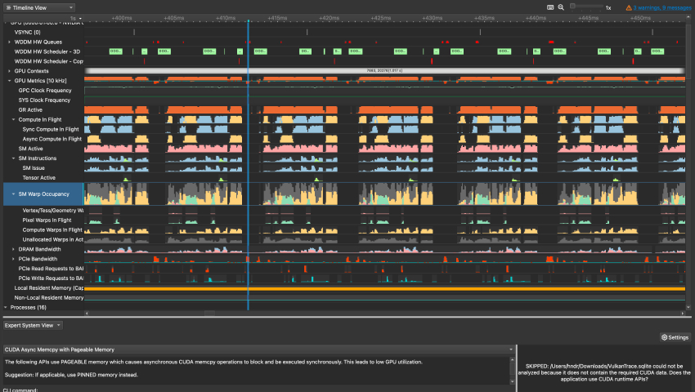
Nsight Systems visualizes system workload metrics on a timeline and provides tools that help developers detect, understand, and solve performance issues.

Profile the System
The full picture of app optimization requires drilling deeply into hardware interactions to ensure maximum parallelism is achieved. Nsight Systems visualizes unbiased, system-wide activity data on a unified timeline, allowing application developers to investigate correlations, dependencies, activity, bottlenecks, and resource allocation to ensure hardware components are working harmoniously.

Analyze Performance
Nsight Systems offers low-overheard performance analysis that visualizes otherwise hidden layers of events and metrics used for pursuing optimizations, including CPU parallelization and core utilization, GPU streaming-multiprocessor (SM) optimization, system workload and CUDA® libraries trace, network communications, OS interactions, and more.

Scale Across Platforms
Nsight Systems is the universal tool for developing applications on NVIDIA platforms, whether on-premises or in the cloud. Scale across a wide range of NVIDIA platforms, from NVIDIA DGX™ to NVIDIA RTX™ workstations, including NVIDIA DRIVE® for automotive and NVIDIA Jetson™ for edge AI and robotics. Nsight Systems provide valuable insights for optimizing AI, high-performance computing (HPC), pro-visualization and gaming applications.

Explore Key Features

Visualize CPU-GPU Interactions
Nsight Systems latches on to a target application to expose GPU and CPU activity, events, annotations, throughput, and performance metrics in a chronological timeline. With low overhead, this data can be visualized accurately and in parallel for ease of understanding. GPU workloads are further correlated with in-application CPU events, allowing for performance blockers to be easily identified and remedied.
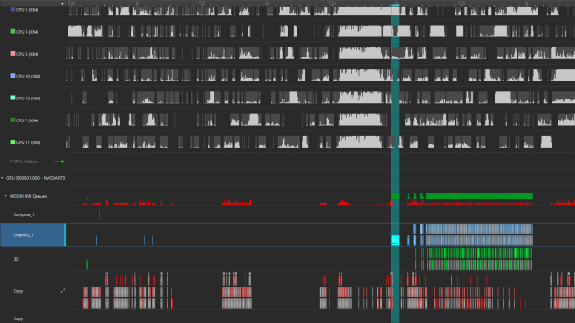
CPU activity (top) in parallel to GPU graphics and compute activity (bottom).
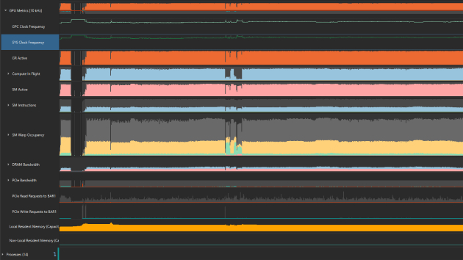
The GPU Metrics section of the Nsight Systems timeline.

Track GPU Activity
To further explore the GPU, toggling on GPU Metrics Sampling will plot low-level input/output (IO) activity such as PCIe throughput, NVIDIA NVLink®, and dynamic random-access memory (DRAM) activity. GPU Metrics Sampling also exposes SM utilization, Tensor Core activity, instruction throughput, and warp occupancy. Every workload and their CPU origin can be readily tracked to support performance tuning.

Trace GPU Workloads
For compute tasks, Nsight Systems supports investigating the CUDA API and tracing CUDA libraries, including cuBLAS, cuDNN, and NVIDIA TensorRT™. For graphics computing, Nsight Systems supports profiling Vulkan, OpenGL, DirectX 11, DirectX 12, DXR, and NVIDIA OptiX™ APIs.
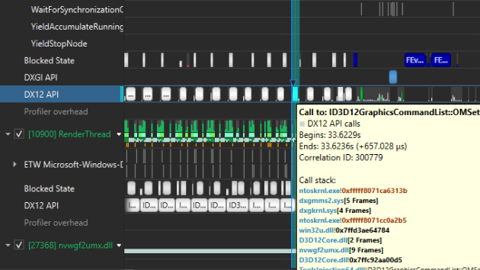
Alt text: DX12 API calls as they happen chronologically in the timeline alongside render thread.

